# Cumulative Statistics (Solution)

This document includes the question, the solution, and a breakdown of the code provided in the screenshot.

## Uploaded Screenshot

Below is the screenshot of the task:

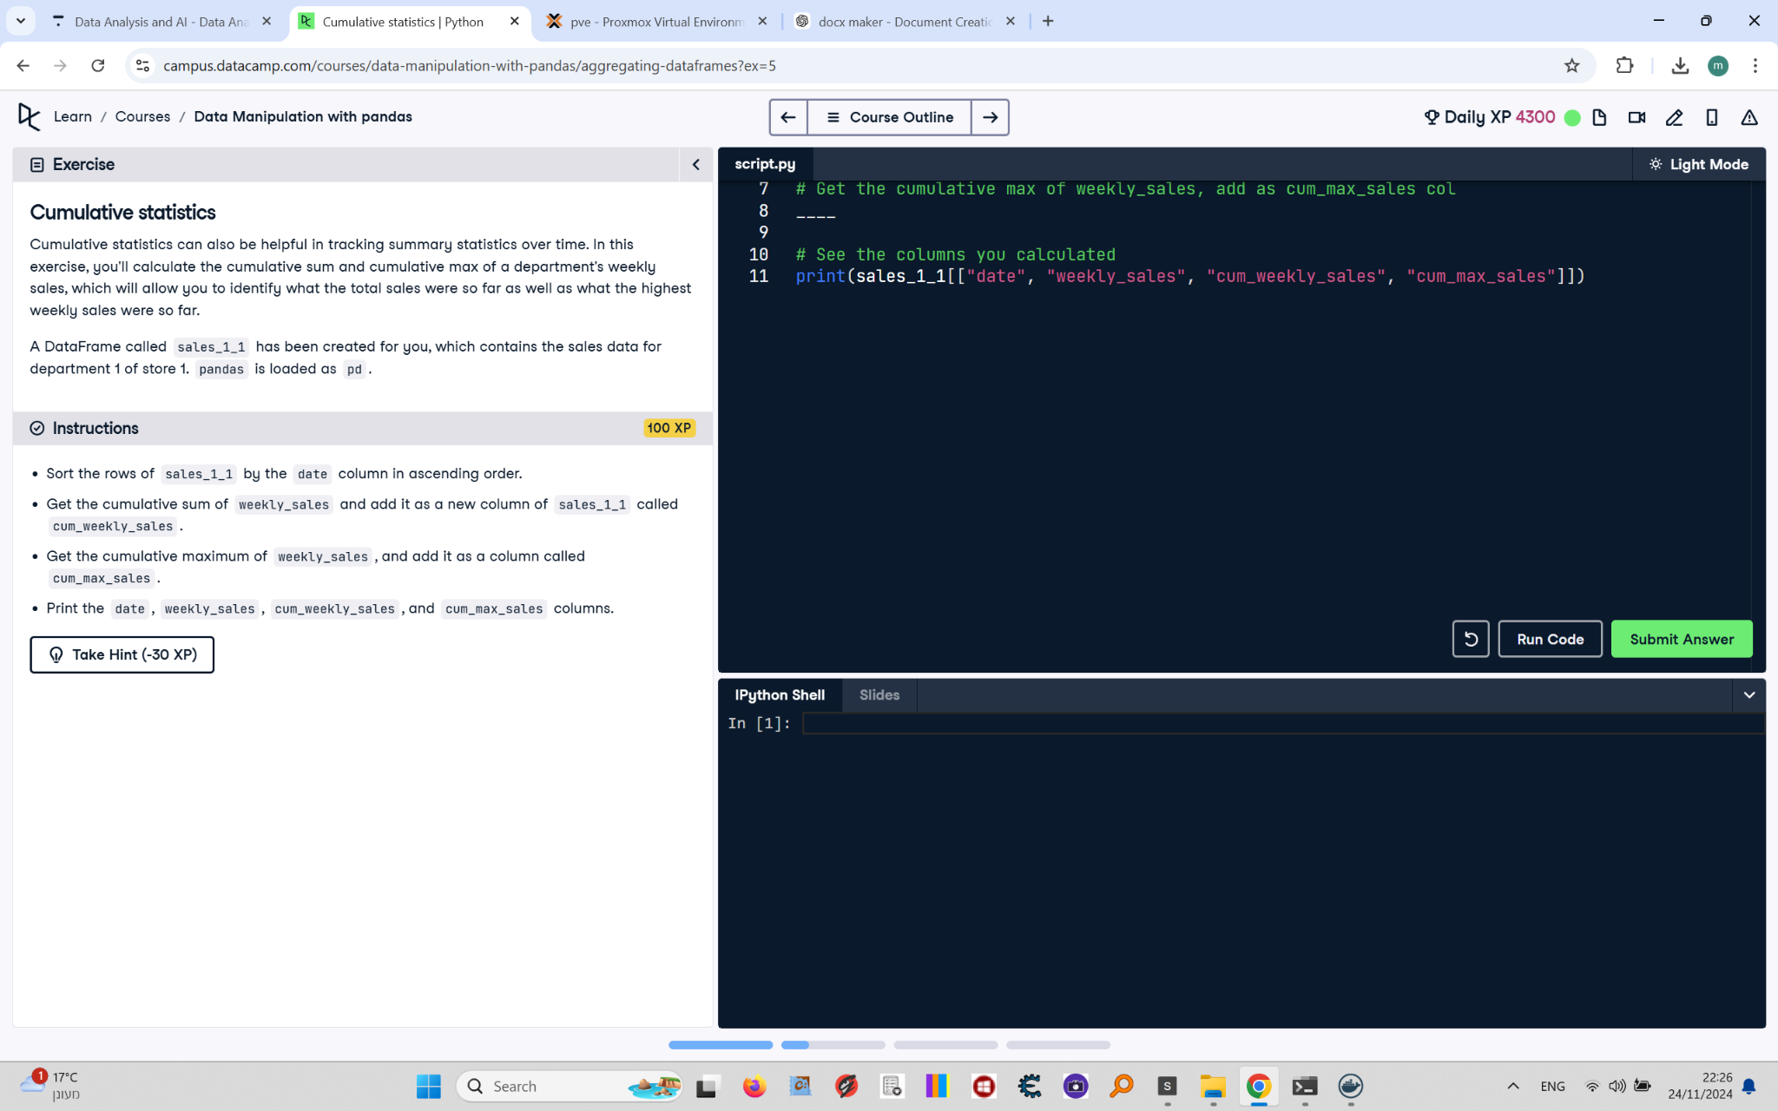

## Question

1. Sort the rows of `sales_1_1` by the `date` column in ascending order.  
2. Get the cumulative sum of `weekly_sales` and add it as a new column of `sales_1_1` called `cum_weekly_sales`.  
3. Get the cumulative maximum of `weekly_sales` and add it as a column called `cum_max_sales`.  
4. Print the `date`, `weekly_sales`, `cum_weekly_sales`, and `cum_max_sales` columns.

## Answer

# Sort rows by date  
sales_1_1 = sales_1_1.sort_values('date')  
  
# Get the cumulative sum of weekly_sales  
sales_1_1['cum_weekly_sales'] = sales_1_1['weekly_sales'].cumsum()  
  
# Get the cumulative maximum of weekly_sales  
sales_1_1['cum_max_sales'] = sales_1_1['weekly_sales'].cummax()  
  
# Print the specified columns  
print(sales_1_1[['date', 'weekly_sales', 'cum_weekly_sales', 'cum_max_sales']])

## Code Explanation

# Explanation of the code:

1. `sales_1_1.sort_values('date')`: Sorts the `sales_1_1` DataFrame by the `date` column in ascending order.

2. `sales_1_1['cum_weekly_sales'] = sales_1_1['weekly_sales'].cumsum()`: Calculates the cumulative sum of the `weekly_sales` column and adds it as a new column called `cum_weekly_sales`.

3. `sales_1_1['cum_max_sales'] = sales_1_1['weekly_sales'].cummax()`: Calculates the cumulative maximum of the `weekly_sales` column and adds it as a new column called `cum_max_sales`.

4. `print(sales_1_1[['date', 'weekly_sales', 'cum_weekly_sales', 'cum_max_sales']])`: Prints the `date`, `weekly_sales`, `cum_weekly_sales`, and `cum_max_sales` columns from the `sales_1_1` DataFrame.